Tara Khela (Start Game): In figure 1, in the star board there are 10 positions or intersections. The positions are randomly numbered. The game starts with 9 pieces, here those are star pieces. The goal is to put all those 9 pieces on the board positions according to the following rules:

1. Start from any empty positions and put a piece at the third position, if the position is empty. For example, we start from position 1 and place the first star in position 10 by going to 1 – 9 – 10 directions, shown in figure 2. We could also place the same position by starting from 4 and going to 4 – 5 – 10 directions. So you can start from any empty position and place at third empty position.
2. You always have to go straight, in any direction, but not otherwise. For example you cannot move 1 – 9 – 2 directions or so.
3. Same rules applied, figure 3, we started from position 7 and placed the star in position 3 by going to 7 – 5 – 3 directions. The same result can be achieved starting form 1, and going to 1 – 2 – 3 directions.

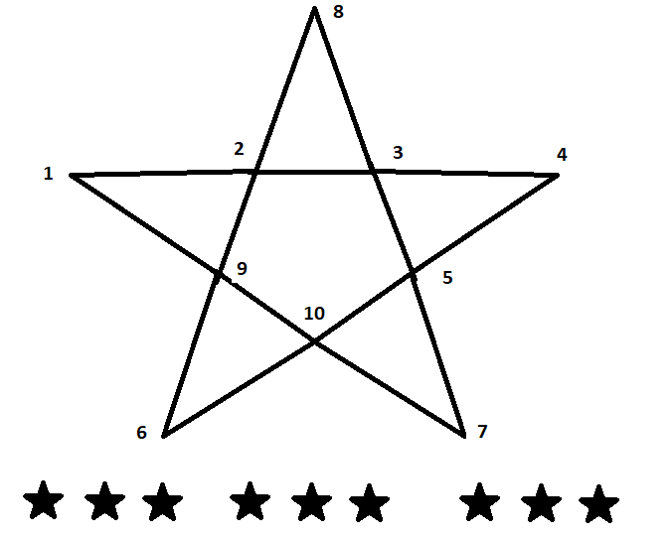

Figure 1: Star board and pieces

1. For figure 4, we can start from 6 and place the star in position 2 by going to 6 – 9 – 2 directions. The same can be achieved by starting from 4 and gong to 4 – 3 – 2 directions.
2. For figure 5, we can start from 5 and place the star in position 8 by going to 5 – 3 – 8 directions. The same can be achieved by starting from 9 and gong to 9 – 2 – 8 directions.
3. So you can jump over a star if it is in the second position, but cannot start or end a position that is already occupied by a piece.
4. From this board position i.e. form figure 5, it is obvious that you cannot put a piece in position 1 or 4, meaning you cannot place all 9 pieces on the board
5. The goal of the game is to put all 9 pieces on the board by following the above rules.

|  |  |
| --- | --- |
|  |  |
| Figure 2 | Figure 3 |
|  |  |
| Figure 4 | Figure 5 |